Main Concept:

this is the first argument of myFunc.bind(thisArg) when invoking a bound function

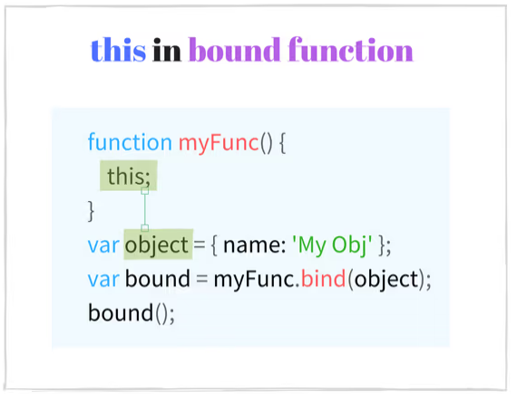

It is a powerful technique that allows creating functions with a predefined this value.

Example Code:

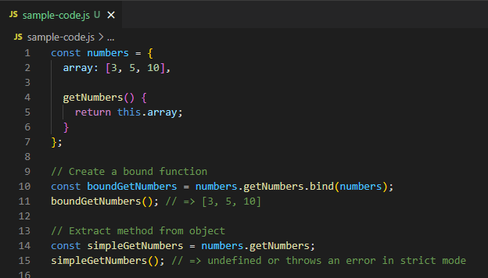

simpleGetNumbers() is a FUNCTION CALL that is why ‘this’ is undefined/error